

May 2nd, 2016

**Rep Alert – 4180/418x promotion**

Dear Sales Partner,

Please find below all the details on a promotion with the 418x IR Calibrators.

**Customer promotion**

**When you now buy the Fluke Calibration 4180 IR Calibrator you can get the 4181 for half the price!**

**Time frame**:   
April 25th – December 31st, 2016

**How to promote:**

* Promotional webpage and banner on FCAL website:   
  [http://eu.flukecal.com/](http://eu.flukecal.com/free-probe-with-metrology-well)node/93751  
  <http://eu.flukecal.com/de/node/94443>

<http://eu.flukecal.com/fr/node/94444>  
<http://eu.flukecal.com/es/node/94445>

<http://ru.flukecal.com/node/94446>

* 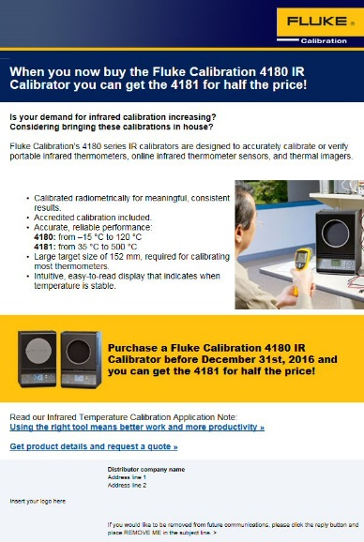Promotional banner on distributors’ websites.  
   If you need the banner in local language or in a different size, please contact gerda.meijer@flukecal.com
* Html mail to end customers  
  Please send to your own customer database

### How to order: Place your order with the text 418x-PROMO

With kind regards,

EMEA Fluke Calibration Team